Name_____________________________________ Date________________________________

BEMSID ___________________________________ Job Code________________________________

Instructions: Fill this assessment out at the start of each topic. At the end of each topic, check your answers and correct if need be.

- Per BAC5000, what is the Sealing Operations certification BSS document? _____________________ (1pt.)
- You will perform a Pressurized Fillet Seal Application at the Extensive level per BAC5000.
  - What are three approved sealant based on this environment? (when not specified on drawing)
(Hint: go to selection of sealant): ___________/_____________/___________ (3pt.)
- Per BAC5000, to remove debris and FOD from the structure, a preliminary cleaning must be done by using this preferred method ________________________. (1pt.)
- Per BAC5000, what solvent is acceptable to do a final clean? _____________________(1pt.)
- Per BAC5000 and final clean. After scrubbing the surface wet with solvent, dry the part off and remove any contaminates before the solvent ________________________ (1pt.)
- Per BAC5000, what are the two approved wipers used for Preliminary and Final Cleaning? ________________________and _________________________________________ (2pt.)
- Per BAC5000, can I use a brush to perform a final clean? ____________________ (1pt.)
- If I drop a part after I cleaned it, is it necessary to re-clean before I apply seal? __________________. (1pt.)
- Per BAC5000, Final Clean needs to be performed ____________________________ before applying promoter or sealant? (1pt.)
- Per BAC5000, what needs to be visibly free of soils and contamination after Final clean is complete? ______________and________________ (CHANGE WIPERS OFTEN). (2pts.)
- Per BAC5000, what needs to be visible and continuous along the joint after a fay seal is applied and fastened together? _________________________________________ (1pt.)
- Per BAC5000, IPA (Isapropyl Alcohol) is a finishing ________________ only and is not used to fair out fillets. (1pt.)
- Per BAC5000, when you apply a fillet, it is important to point the nozzle into the seam and push the bead ahead of the nozzle to minimize what? ___________________________ (DO NOT PULL SEALANT) (1pt.)
- Per BAC5504, Brushcoat should be visible and extends ________inch to ________ inch beyond Class B sealant after completion of sealing. (2pt.)
- Per BAC5504, not applying First Fillets where required can cause in-service __________________________ (1pt.)

Body seal fillet dimensions BAC5000

- w- Dimension = _______________ (1pt.)

- d- Dimension = _______________ (1pt.)

- When is the a-dimension required? When your structure is less than _______ inches (1pt.)

- a- Dimension = _______________ (1pt.)

- What are the fastener sealing dimensions? (2pt.)
- Top ___________________
- Base __________________

- W-dimension ___________ inches (1pt.)

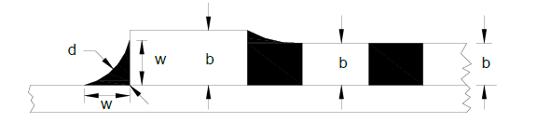
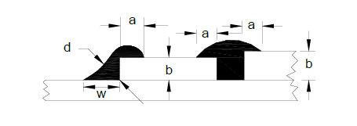
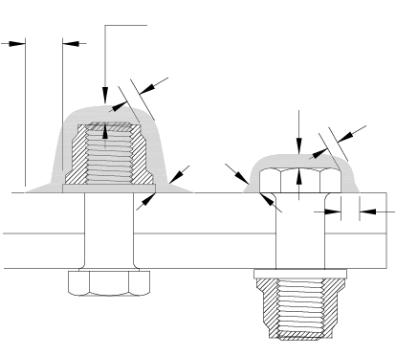

Fuel tank fillet & fastener seal dimensions BAC5504
- w- Dimension= ___________________ (1pt.)

- h- Dimension= ____________________ (1pt.)

- d- Dimension= ________________(1pt.)

- When is a first fillet not required?
When your structure is less than ______________ inches. (1pt.)

- When is the a-dimension required?
When your structure thickness is ______________ inches or less. (1pt.)

- a- Dimension= ____________________ (1pt.)

- What are the fastener sealing dimensions? (2pt.)
- d = ___________________
- t = ___________________

- How much brushcoat should be visible after application of a full body fillet and fastener seals? _______________ (1pt.)

