Instructor’s Manual: 5S Lean Manufacturing Course

Kristina Young
Colorado State University
EDAE 639: Instructional Design
Dr. Tobin Lopes
April 8, 2024

Table of Contents
Instructor’s Manual Overview: 5S Lean Manufacturing Course 4
Course Overview 4
Goals and Objectives 4
Schedule 5
Agenda 6
Learning Materials 6
Activities, Assessments, and Evaluations 7
Course Facilitation Sessions 8
Course Preparation and Setup 8
Introductions and Course Overview 10
Understanding 5S Lean 10
Applying 5S Lean Principles and Practices 11
Manufacturing Factory Tour and Post Discussion 12
Implementing 5S Lean into CTE Classrooms 12
CTE and Industry 5S Lean Collaborations 13
Wrap-Up, Feedback, and Course Evaluation 14
References 15
Appendix 16
Instructor’s Manual Overview: 5S Lean Manufacturing Course
Welcome to the "5S Lean Manufacturing" instructor's manual. As an industry expert poised to deliver this pivotal training, you hold the key to equipping high school Career and Technical Education (CTE) teachers with the tools and insights needed to bring the principles of 5S Lean manufacturing to life in their classrooms.
This guide is meticulously designed to support you in conducting a dynamic and impactful one-day course that aligns with the Core Plus Aerospace (CPA) curriculum. By facilitating an understanding rooted in real-world applications, you will be guiding participants through a transformative experience — enabling them to not only grasp but also apply 5S methodologies within their teaching domains. Within these pages lies a strategic blend of theoretical knowledge, practical activities, and assessments, all structured to ensure that educators can foster environments of efficiency and innovation. Let this manual serve as your compass as you lead the charge in shaping the future of 5S Lean education.

Course Overview
Goals and Objectives
This course is designed to equip high school CTE educators with the expertise to seamlessly integrate 5S Lean manufacturing principles and practices into their CPA curriculum as well as foster collaboration between instructors and industry partners to enhance the practical application of 5S Lean principles. In order to achieve these goals, learners should be able to meet the following objectives by the end of this course:
- Demonstrate proficiency in the application of 5S Lean principles, as evidenced by a visible reduction in clutter and production waste within their classroom environments.
- Incorporate hands-on 5S Lean activities into their teaching methods, aligning these activities with existing instructional approaches.
- Develop a comprehensive action plan outlining strategies for sustaining 5S Lean practices in their classrooms, including regular audits and integration into the curriculum, with the aim of fostering a lasting culture of continuous improvement.
- Establish meaningful industry partnerships, leading to collaborative projects that integrate real-world 5S Lean practices into classroom activities.
- Identify and address common challenges in implementing 5S Lean principles, resulting in actionable strategies to overcome barriers, through the use of facilitated discussions and workshops.
- Conduct classroom visits with industry experts to receive guidance on effective 5S Lean integration, ultimately increasing instructor confidence in incorporating industry-relevant practices into their curriculum.

Schedule
The "5S Lean Manufacturing" course spans an engaging 8-hour period, commencing at 8:00 AM and concluding at 4:30 PM. Hosted in the dedicated training classroom of a manufacturing industry site, the session is designed to foster an interactive and focused learning atmosphere. Participants will be given opportunities to refresh and network during two 10-minute breaks, as well as a 30-minute lunch break to recharge. A key feature of the day is a guided tour of the manufacturing facility, offering a practical glimpse of 5S principles at work. The course will circle back to the training classroom, where discussions and applications of the day's observations can be integrated into teaching strategies for the CPA curriculum.
Here is the course schedule at a glance:
- Duration: 8 hours.
- Timing: 8:00 AM - 4:30 PM.
- Breaks: Two 10-minute breaks and one 30-minute lunch break.
- Location: Manufacturing industry site training classroom and factory visit.

Agenda:
This agenda serves as a high-level guide for facilitators conducting the 5S Lean Manufacturing course. It provides a framework for the day’s activities, allowing instructors to prepare for the detailed schedule and teaching moments ahead.
Here is the daily agenda:
- 07:00 AM – 8:00 AM: Course Preparation and Setup
- 08:00 AM - 08:40 AM: Introductions and Course Overview.
- 08:40 AM - 10:00 AM: Understanding 5S Lean.
- 10:00 AM - 10:10 AM: Break.
- 10:10 AM - 12:00 PM: Applying 5S Lean Principles and Practices.
- 11:50 AM – 12:00 PM: Formative Assessment
- 12:00 PM - 12:30 PM: Lunch Break.
- 12:30 PM - 01:50 PM: Manufacturing Factory Tour and Post Discussion.
- 01:50 PM - 02:50 PM: Implementing 5S Lean into CTE Classrooms.
- 02:50 PM - 03:00 PM: Break.
- 03:00 PM - 04:00 PM: CTE and Industry 5S Lean Collaborations.
- 04:00 PM - 04:30 PM: Wrap-Up, Feedback, and Course Evaluation.

Learning Materials
To ensure a successful and interactive learning experience, facilitators are provided with a variety of materials designed to support the delivery of the 5S Lean Manufacturing course. These resources have been carefully curated to cater to the diverse learning styles within the classroom and to facilitate a comprehensive understanding of the 5S principles.
Here is a list of learning materials to have on hand to facilitate this course:
- Course PowerPoint presentation.
- Projector and projection screen.
- Presentation clicker (and extra batteries).
- Access to whiteboards or flipcharts.
- Safety glasses and ear protection for all.
- Factory tour map.
- Laptops for each student.
- Guest internet access logins for each student.
- 5S Lean Manufacturing course packet for students.
- Notebooks for each student.
- Packet of blank paper.
- Pens or pencils and markers.
- Prediction/Anticipation guides (see Appendix H) (AdLit, 2023; Barkley & Major, 2016).
- IRA worksheets (see Appendix J) (Barkley & Major, 2016).
- Headphones for each student.
- Role play scripts and props (Barkley & Major, 2016).
- Peer problem review index cards (see Appendix I) (Barkley & Major, 2016; Formsbirds, 2024).
- Large poster paper.
- QR Code and link for online course feedback form (in presentation).

Activities, Assessments, and Evaluations
As a facilitator, your role is pivotal in guiding participants through a journey of learning and application of 5S Lean Manufacturing principles. Below is a curated list of activities, assessments, and evaluations designed to engage participants, evaluate their understanding, and empower them to integrate 5S Lean practices into their teaching environments. Each element is structured to build upon the previous, ensuring a cohesive learning experience that culminates in the practical application and continuous improvement of 5S methodologies in educational settings. Please reference this list throughout the course to align your instructional approach with the participants' learning and development objectives. Here is a list of activities/assessments used in this course:
- Prediction/Anticipation Guide: To evaluate proficiency in 5S Lean principles, occurring at the beginning and revisited at the end of the first module to assess prior knowledge and learning progress (AdLit, 2023; Barkley & Major, 2016) (see Appendix H). Used to assess the first course objective.
- Sequence Chains: Participants use this method to develop their ability to integrate 5S Lean activities into their teaching methods (Barkley & Major, 2016) (see Appendix I). Used to assess the second course objective.
- Insights-Resources-Applications (IRAs): Participants use this method to develop comprehensive action plans for sustaining 5S Lean practices, detailing strategies for regular audits and curricular integration (Barkley & Major, 2016) (see Appendix J). Used to assess the third course objective.
- Digital Projects: Participants use this method for establishing industry partnerships by showcasing collaboration with industry and incorporation of 5S Lean practices into classroom activities and processes (Barkley & Major, 2016) (see Appendix K). Used to assess the fourth course objective.
- Role Playing: This method allows participants to address common challenges in implementing 5S Lean principles through simulated scenarios (Barkley & Major, 2016) (see Appendix L). Used to assess the fifth course objective.
- Peer Problem Review: Participants engage in peer reviews of their 5S implementation plans, incorporating insights from industry experts' classroom visits for effective 5S Lean integration (Barkley & Major, 2016) (see Appendix M). Used to assess the sixth course objective.
- Formative Assessment: This assessment is used to determine if the learners have achieved the new learning skills at the specific halfway point in the course. It will be used by the facilitator to determine if they need to adjust the training to ensure learners gain the skills to be able to continue on in the rest of the new course content.
- Manufacturing Factory Tour: This activity allows participants to connect their learning to real-world examples as well as challenges them to identify additional 5S Lean improvements.
- Course Final Evaluation: This is a summative evaluation of the course and the learners to determine if the training achieved the objectives and goals set forth. The data captured will be used to determine continuous improvements to the course.
- Post-Course Evaluation: This visit takes place in CPA classrooms by industry subject matter experts (SMEs) to assess the practical application of 5S Lean principles in the participants CTE class six months after the completion of this course. This also includes feedback activities to gauge the long-term impact of the course.
Course Facilitation
Course Preparation and Setup (7:00 AM – 8:00 AM)
Course facilitators are advised to arrive at the venue no later than 7:00 AM to ensure ample time for setting up the classroom and preparing for a successful day of instruction. This hour of preparation is crucial for creating an environment conducive to learning and engagement. The objective is to establish a well-organized and technology-ready learning environment to ensure a seamless and interactive educational experience. Here is a list of instructor actions and materials:
- Classroom Setup: Arrange desks and seating to facilitate easy viewing of presentations and encourage participant interaction.
- Presentation Preparation: Test all audiovisual equipment, including the projector and sound system, to ensure clear visibility and audio for video materials.
- Presentation Clicker Check: Verify the functionality of the presentation clicker to manage slideshow transitions smoothly.
- Technology Setup: Position student laptops at each desk, connect them to battery chargers, ensure internet connectivity, and attach a mouse to each unit for navigational ease.
- Material Organization: Print all activity handouts and course packets.
- Resource Distribution: Place additional paper, notebooks, and writing utensils at each participant's desk to enable notetaking and participation in activities throughout the course.
- Environment Adjustment: Optimize classroom lighting for both screen visibility and notetaking as well as adjust the temperature to maintain comfort for all participants.
Once the setup is complete, facilitators should review the day's agenda one final time to ensure a clear understanding of the course flow. By the start of the course, the classroom should be welcoming, with all materials accessible, ensuring participants can dive straight into the learning experience. As a reminder, facilitators should remain adaptable to any unforeseen circumstances, ensuring they can respond promptly and maintain the schedule and learning atmosphere.
Introductions and Course Overview (8:00 AM – 8:40 AM)
The main objectives in this learning session are to get to know the participants, assess their prior knowledge on the topic by completing the “Before” portion of the Prediction/Anticipation Guide (see Appendix H), and ensuring a safe learning environment for the students before transitioning into the training (AdLit, 2023; Barkley & Major, 2016). The facilitator should review the course goals, objectives, topics, and activities that will take place in the course as well as set expectations for the day's learning experience. Refer to the “Introduction and Course Overview Detailed Schedule” (see Appendix A) for a detailed schedule of the tasks and materials needed to carry out this learning session.
Understanding 5S Lean (8:40 AM – 10:00 AM)
This session is designed to immerse participants in the fundamental principles of 5S Lean manufacturing. The main objective of the learning is to provide an essential introduction to 5S methodologies and connect these principles to their historical roots as well as their current applications in manufacturing practices. To accomplish this, the facilitator will effectively convey the "5S Lean Introduction" content using the course PowerPoint presentation.
The facilitator’s role also includes fostering interactive learning through the Insights-Resources-Applications (IRAs) activity (Barkley & Major, 2016). The facilitator should provide a clear explanation of the IRAs method, using the presentation slides, and guide participants through the online article "The 5S Methodology," and the embedded YouTube video within (Patrick, 2020; Steele, 2020). This multi-modal approach ensures participants not only receive information but also actively engage with the material by completing the IRAs worksheet (see Appendix J), thereby reinforcing their learning through application of concepts (Barkley & Major, 2016). Headphones are provided to facilitate focused viewing of the video, suggesting an intent for participants to engage with the content individually for a period of reflection and self-paced learning. Refer to the “Understanding 5S Lean Detailed Schedule” (see Appendix B) for a detailed schedule of the tasks and materials needed to carry out this learning session.
Applying 5S Lean Principles and Practices (10:10 AM – 11:50 PM)
This session is structured to provide participants with an interactive and collaborative learning experience. It is split into two main assessment activities: Role Play and Peer Problem Review (Barkley & Major, 2016; Formsbirds, 2024).
During the Role Play Activity, the facilitator’s role is to create a dynamic learning environment where participants can embody and enact scenarios that illustrate the 5S Lean principles (Barkley & Major, 2016) using Role Play Activity Index Cards (see Appendix L). This requires the facilitator to first review the presentation slides to set the stage and clarify the objectives of the activity. They must then curate role play scenarios that accurately reflect real-world applications of 5S Lean, assign roles to participants, and provide adequate preparation time. The facilitator is also responsible for observing the role plays, gathering insightful feedback, and leading a class discussion to reflect on the scenarios and share the feedback collected. The materials provided, such as role play scripts, props, and notebooks, are intended to support the participants in this immersive learning process.
For the Peer Problem Review assessment activity, the facilitator transitions to guiding participants through problem-solving using the 5S Lean principles (Barkley & Major, 2016; Formsbirds, 2024). This includes a review of presentation slides for a consistent knowledge foundation, distribution of Peer Problem Review Activity Index Cards (see Appendix M) to present specific challenges, and steering the participants as they work through these problems individually (Barkley & Major, 2016; Formsbirds, 2024). The facilitator then orchestrates a peer review process, where solutions are exchanged and discussed among participants. This encourages collaboration, critical thinking, and the practical application of 5S Lean concepts, with notebooks and blank paper serving as tools for participants to document their solutions and feedback. The exchange of ideas and peer feedback is central to reinforcing understanding and fostering a community of practice among the learners. Refer to the “Applying 5S Lean Principles and Practices Detailed Schedule” (see Appendix C) for a detailed schedule of the tasks and materials needed to carry out this learning session.
Formative Assessment (11:50 AM – 12:00 PM)
Learners will participate in a formative assessment to determine if they meet the learning stage they should be at by this point in the training. The facilitator will use this information to gage if more training needs to take place or if specific items need to be reviewed with the learners prior to moving on to new course content.
Manufacturing Factory Tour and Post Discussion (12:30 PM – 1:50 PM)
This session is an immersive experience aimed at connecting theoretical knowledge of 5S Lean principles with real-world manufacturing practices. The facilitator begins by briefing participants on safety and educational objectives, using PowerPoint slides to emphasize key 5S elements to observe. Safety glasses and earplugs are distributed to ensure a safe tour experience.
During the factory tour, the facilitator leads the participants through the site, encouraging identification and discussion of 5S principles. Participants are advised to take detailed notes that will support their future digital projects activity (Barkley & Major, 2016).
The session concludes with a reflection and group discussion where participants regroup, share their observations, and discuss potential areas for 5S Lean improvements. This collaborative discussion is instrumental in reinforcing the practical applications of 5S Lean principles and fostering a collective learning environment. Refer to the “Manufacturing Factory Tour and Post Discussion Detailed Schedule” (see Appendix D) for a detailed schedule of the tasks and materials needed to carry out this learning session.
Implementing 5S Lean into CTE Classrooms (1:50 PM – 2:50 PM)
For this session, the central learning objective is for participants to integrate 5S Lean principles into their CTE classrooms by crafting detailed visual maps, in which the Sequence Chains activity will be used (Barkley & Major, 2016) along with the Sequence Chains Worksheet (see Appendix I). The facilitator introduces the Sequence Chains Learning method with PowerPoint slides and then guides participants to create individual sequence chains, linking 5S concepts to their specific CPA class lesson plans (Barkley & Major, 2016). The facilitator allocates time for hands-on creation, followed by a collaborative segment for group sharing and feedback. Utilizing materials like large poster paper, colored markers, and illustrative slides, the facilitator's role is pivotal in steering the learning experience, fostering a creative atmosphere for idea generation, and orchestrating a dialogue to reflect on the practical application of the 5S activities designed during the session. Refer to the “Implementing 5S Lean into CTE Classrooms Detailed Schedule” (see Appendix E) for a detailed schedule of the tasks and materials needed to carry out this learning session.
CTE and Industry 5S Lean Collaborations (3:00 PM – 4:00 PM)
For this session, the facilitator's goal is to guide participants in creating a digital project that demonstrates their grasp of 5S Lean principles, especially in the context of industry collaboration (Barkley & Major, 2016). The session begins with a review of industry collaboration principles using PowerPoint slides, including examples of digital projects. Participants are then led through the process of brainstorming and planning their own digital projects, with discussions on the possible types they can undertake (Barkley & Major, 2016). As they work on their projects, the facilitator is on hand to provide support and answer questions. Finally, participants submit their projects by emailing to the facilitator and having volunteers showcasing their work to the class. This session highlights practical applications of 5S Lean practices in educational settings. Materials for the activity include laptops with internet access, digital project guidelines, and sample projects displayed in PowerPoint slides. Refer to the “CTE and Industry 5S Lean Collaborations Detailed Schedule” (see Appendix F) for a detailed schedule of the tasks and materials needed to carry out this learning session.
Wrap-Up, Feedback, and Course Evaluation (4:00 PM – 4:30 PM)
In the Course Wrap-Up and Feedback session, the instructor will conclude the day by refocusing on the second portion of the Prediction/Anticipation Guides from the beginning of the course (AdLit, 2023; Barkley & Major, 2016). Participants will complete the "After" section to discuss outcomes and share insights, allowing the instructor and students to gauge the knowledge gained. This is followed by a summarization of the day's learning and the collection of feedback through an online survey to assess the training's effectiveness. The instructor will thank participants, outline post-course support, and distribute course summaries, ensuring a comprehensive close to the session as well as remind participants of the post-course SME visit which will take place six months later. Refer to the “Course Wrap-Up and Feedback Detailed Schedule” (see Appendix G) for a detailed schedule of the tasks and materials needed to carry out this learning session.

References
AdLit. (2023). Anticipation guide template. Anticipation Guides. Retrieved March 20, 2024, from https://www.adlit.org/in-the-classroom/strategies/anticipation-guides.
Barkley, E. F., & Major, C. H. (2016). Learning assessment techniques: A handbook for college faculty. Jossey-Bass.
Formsbirds.com. (2024). Index cards template. FormsBirds. https://www.formsbirds.com/download-index-cards-template.
Patrick, K. (2020, October 14). What is the 5s methodology and how does it apply to lean six sigma and beyond? YouTube. https://www.youtube.com/watch?v=ddKVNOmrwkI&t=2s.
Steele, C. (2020, October 14). The 5s methodology. GoSkills.com. https://www.goskills.com/Lean-Six-Sigma/Resources/5S.

Appendix A
Introduction and Course Overview Detailed Schedule (8:00 AM – 8:40 AM)
Participants Arrive
8:00 AM
Tasks:  • Instructor greets participants as they arrive.  • Directs students to select a seat.  • Have them fill out their name tag.  • Login to their computers. | Materials:  • Name tags.  • Markers.  • Laptop for each student.  • Guest internet password and login info for each student taped to laptop.
Welcome and Introductions
8:00 AM - 8:15 AM
Tasks:  • Use the Welcome and Introduction PowerPoint slides to introduce facilitator, name of course, and welcomes everyone to class.  • Have students sign the course roster.  • Review safety and evacuation plan slides.  • Share bathroom locations and break area slides.  • Show facilitator “diversity blueprint” or “about me” slide sharing background information and 5S experience.  • Conduct around the room student introductions using presentation slide and students briefly share name, school they're from, and 5S background. | Materials:  • Projector and screen.  • Laptop or desktop computer.  • Presentation clicker and extra batteries.  • Course PowerPoint presentation Welcome and Introduction slides.  • Student course packet.  • Course PowerPoint presentation.
Prediction/Anticipation Guide Activity (“Before” section)
8:15 AM - 8:25 AM
Tasks:  • Handout the Prediction/Anticipation Guide (AdLit, 2023; Barkley & Major, 2016).  • Explain to the students they will get the answers at the end of the course and to try their best to fill out the form to the best of their knowledge.  • Have students quickly fill out the “Before” section of the form.  • When time is up, the facilitator will collect the guides (ensuring student name is on it).  • Save these to be used again at the end of the course. | Materials:  • Pens or pencils.  • Prediction/Anticipation Guide handout (see Appendix H) (AdLit, 2023; Barkley & Major, 2016).
Course Overview
8:25 AM - 8:35 AM
Tasks:  • Present a brief overview of the course using the PowerPoint slides provided for course overview.  • Review course goals and objectives.  • Review agenda and activities.  • Review what time breaks and lunch will be and cafeteria location.  • Review ground rules and expectations. | Materials:  • Projector and screen.  • Laptop or desktop computer.  • Presentation clicker and extra batteries.  • Course PowerPoint presentation - Course overview slides.  • Student course packet.  • Pens or pencils.  • Blank paper for notetaking.
Student Q&A
8:35 AM - 8:40 AM
Tasks:  • Allow time for any immediate questions participants may have regarding the course, logistics, or anything else that come up. | Materials:  • Projector and screen.  • Laptop or desktop computer.  • Presentation clicker and extra batteries.  • Course PowerPoint presentation - Q&A slide.  • Pens or pencils.  • Blank paper for notetaking.

Appendix B
Understanding 5S Lean Detailed Schedule (8:40 AM – 10:00 AM)
5S Lean Introduction
8:40 AM – 9:30 AM
Tasks:  • Instructor presents the PowerPoint slides for the Introduction to 5S Lean.  • Describe the five S’s.  • Discuss the historical context and relevance to current manufacturing practices.  • Address different types of waste.  • Discuss risks and benefits.  • Provide examples in relation to a manufacturing and classroom setting to help educators identify relevancy in the learning content. | Materials:  • Course PowerPoint presentation slides for 5S Lean Introduction.
Insights-Resources-Applications (IRAs) Activity
9:30 AM – 10:00 AM
Tasks:  • Use the course PowerPoint slides on IRAs to explain the method and what students will do to complete this activity.  • Show slide that has the link for students to access the online article “The 5S Methodology” (students should watch the embedded YouTube video in the article too) (Patrick, 2020; Steele, 2020).  • Pass out the IRAs worksheet  • Have students read the article, watch the video, and complete the IRAs worksheet.  • Discuss as a class what the students have gained from the learning activity and answer any questions they may have. | Materials:  • IRA worksheet (see Appendix J) (Barkley & Major, 2016).  • Course PowerPoint slides for IRAs.  • Link to online article (in presentation)(YouTube video is embedded in article) (Patrick, 2020; Steele, 2020).  • Headphones for each student.
Break
10:00 AM – 10:10 AM
Tasks:  • Ensure participants take a break to refresh.  • Start the presentation count down time or provide students with the time they should be back.  • Remind students where restrooms and break areas are located.  • Prepare materials for the next session during this time. | Materials:  • Count down timer or bell to signal the end of the break.
Appendix C
Applying 5S Lean Principles and Practices Detailed Schedule (10:10 AM – 12:00 PM)
Role Play Activity
10:10 AM – 11:30 AM
Tasks:  • Review the presentation slides and explain the activity and what the students will be doing.  • Set up role play scenarios based on 5S Lean principles.  • Assign roles to participants and provide time for preparation.  • Facilitate role play execution, observing and taking notes for feedback.  • Conduct class discussion and share observed feedback. | Materials:  • Course PowerPoint presentation slides for Role Play Activity.  • Role Play Activity Index Cards (see Appendix L) and props (Barkley & Major, 2016).  • Notebooks or blank paper
Peer Problem Review Activity
11:30 AM – 12:00 PM
Tasks:  • Review the presentation slides and explain the activity and what the students will be doing.  • Distribute the Peer Problem Review index cards (one to each participant).  • Observe students and guide them through solving the problems as needed.  • Conduct class discussion. | Materials:  • Course PowerPoint presentation slides for Peer Problem Review Activity.  • Peer Problem Review Index Cards (see Appendix M) ( Barkley & Major, 2016; Formsbirds, 2024).  • Notebooks or blank paper
Formative Assessment
11:50 PM – 12:00 PM
Tasks:  • Show the slide with the Formative Evaluation QR code (and link in case code can’t be accessed)  • Have students complete the online evaluation.  • Facilitators determine if course adjustments and/or learning review is needed based on online results. | Materials:  • Course PowerPoint presentation slides for Formative Evaluation.  • Online Summative Course Evaluation QR code and Link
Lunch Break
12:00 PM – 12:30 PM
Tasks:  • Ensure participants take a break to refresh.  • Start the presentation count down time or provide students with the time they should be back.  • Prepare materials for the next session during this time. | Materials:  • Count down timer or bell to signal the end of the break.

Appendix D
Manufacturing Factory Tour and Post Discussion Detailed Schedule (12:30 PM – 1:50 PM)
Preparation and Briefing
12:30 PM – 12:40 PM
Tasks:  • Present course PowerPoint slides on Manufacturing Factory Safety making sure to remind participants not to use their phones, photography is not allowed on site, and to make sure they stay with the facilitator at all times (do not wander off).  • Brief participants on what to look for during the tour, emphasizing the 5S principles in a live environment.  • Distribute safety glasses and ear plugs. | Materials:  • Course PowerPoint presentation slides for Manufacturing Factory Safety.  • Notebooks.  • Pens or pencils.  • Safety glasses.  • Ear plugs.
Manufacturing Factory Tour
12:40 PM – 1:30 PM
Tasks:  • Conduct a tour of the manufacturing site, asking students to point out examples and also asking questions to keep learners engaged and talking about what they observe.  • Encourage participants to take notes for reference in their upcoming digital projects activity later on in the course. | Materials:  • Factory map highlighting tour walking path.  • Notebooks.  • Pens or pencils.  • Safety glasses.  • Ear plugs.
Post Factory Tour Reflection and Group Discussion
1:30 PM – 1:50 PM
Tasks:  • Ensure all participants are accounted for when arriving back at the classroom after the tour.  • Allow about 5 minutes for students to settle back in and reflect on the notes they took (students can also use the restroom if needed during this time).  • For the rest of this activity, conduct a class discussion asking if any participants want to volunteer to share what they observed and if they identified any needed 5S Lean improvements. | Materials:  • Notebooks with students notes from the tour.

Appendix E
Implementing 5S Lean into CTE Classrooms Detailed Schedule (1:50 PM – 2:50 PM)
Sequence Chains Activity
1:50 PM – 2:50 PM
Tasks:  • Present course PowerPoint slides for the Sequence Chains activity and review examples.  • Instruct participants to individually create a visual map using poster paper and marks by detailing the integration of a 5S activity of their choosing into their CPA lesson plan.  • Spend the last 20 minutes sharing as a group what each learner came up, allowing learners to share feedback to their classmates. | Materials:  • Course PowerPoint presentation slides for Sequence Chains (Barkley & Major, 2016).  • Examples of past class sequence chains if available.  • Sequence Chains Worksheets (see Appendix I)  • Large poster paper.  • Markers.
Break
2:50 PM – 3:00 PM
Tasks:  • Ensure participants take a break to refresh.  • Start the presentation count down time or provide students with the time they should be back.  • Prepare materials for the next session during this time. | Materials:  • Count down timer or bell to signal the end of the break.

Appendix F
CTE and Industry 5S Lean Collaborations Detailed Schedule (3:00 PM – 4:00 PM)
Digital Projects Activity
3:00 PM – 4:00 PM
Tasks:  • Present course PowerPoint slides on Industry Collaboration by describing the Digital Projects activity and sharing examples.  • Instruct participants on creating a digital project that reflects their understanding and application of 5S Lean principles through collaboration with current and/or future partnerships.  • Provide time for brainstorming and initial planning of their digital projects.  • Discuss the types of digital projects participants can create.  • Participants work on their digital projects, using laptops and online resources to craft a digital project showcasing their industry collaborations to incorporate 5S Lean practices into their classroom activities.  • Participants will email their completed projects to the instructor when complete.  • A few volunteers will present their digital project concepts in front of the class (instructor access their emailed project to show on the projector for the students). | Materials:  • Course PowerPoint presentation slides for Industry Collaboration and Digital Projects activity examples (Barkley & Major, 2016).  • Laptops for each learner with internet access.  • Instructor’s email for students to send completed projects.  • Digital Projects Activity Handout (see Appendix K)

Appendix G
Course Wrap-Up and Feedback Detailed Schedule (4:00 PM – 4:30 PM)
Prediction/Anticipation Guide (“After” section)
4:00 PM – 4:15 PM
Tasks:  • The instructor will pass back the students previously collected Prediction/Anticipation Guides from the start of the course (AdLit, 2023; Barkley & Major, 2016).  • Students will complete the “After” section of the form.  • Facilitator will share the correct answers with the class.  • Allow students to reflect on the activity. Discuss what surprised them about the results from the “Before” versus the “After”. Did they gain new knowledge?  • The instructor will collect the completed forms to use for training data collection. | Materials:  • Pens or pencils.  • Prediction/Anticipation Guide handout (see Appendix H) (AdLit, 2023; Barkley & Major, 2016).
Wrap-Up, Feedback, and Course Evaluation
4:15 PM – 4:30 PM
Tasks:  • Using the course PowerPoint slides for Course Review and Wrap-Up, summarize the day’s activities and key takeaways.  • Check in with learners to see if there are any additional questions.  • Show the slide with the Summative Course Evaluation QR code (and link to survey in case code can’t be accessed)  • Have students complete the online feedback evaluation.  • Students must shut down their laptops and help clean up the classroom prior to leaving for the day. | Materials:  • Course PowerPoint presentation slides for Course Review and Wrap-Up.  • Online Summative Course Evaluation QR code and Link

Appendix H
Prediction/Anticipation Guide Activity
(AdLit, 2023; Barkley & Major, 2016)
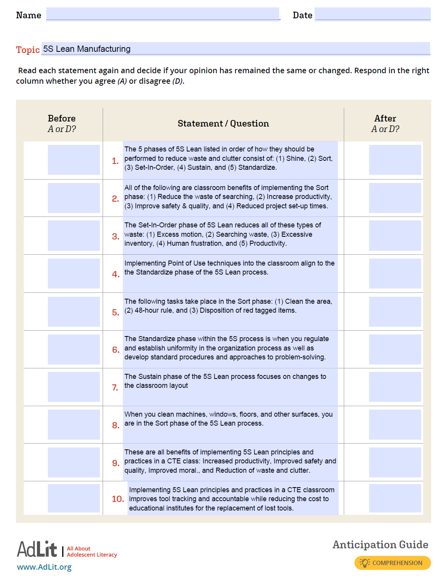
Appendix I
Sequence Chains Worksheet
(Barkley & Major, 2016)
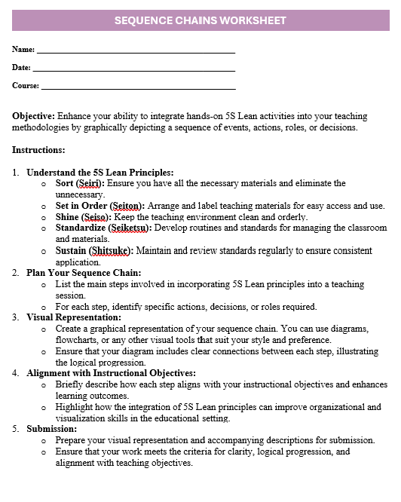
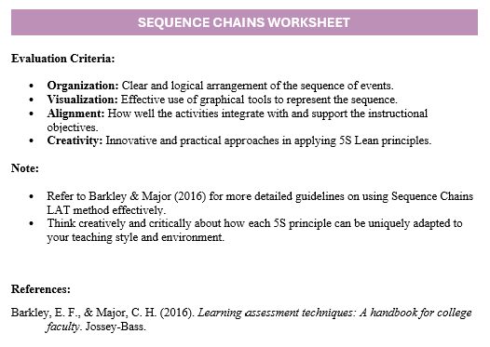

Appendix J
IRAs Worksheet
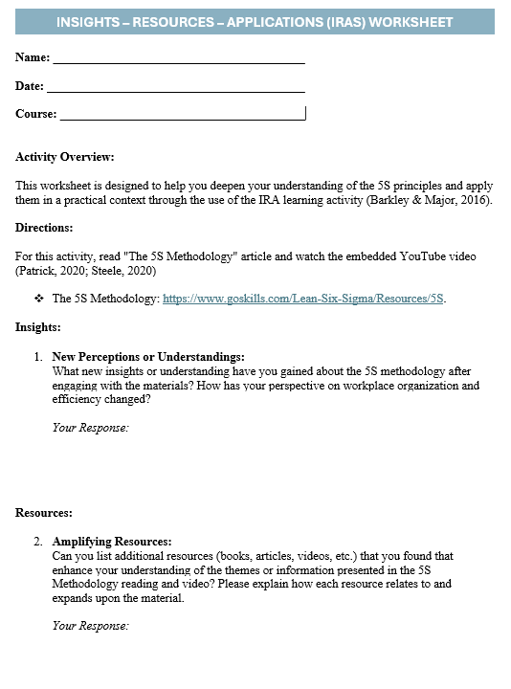
(Barkley & Major, 2016; Patrick, 2020; Steele, 2020)

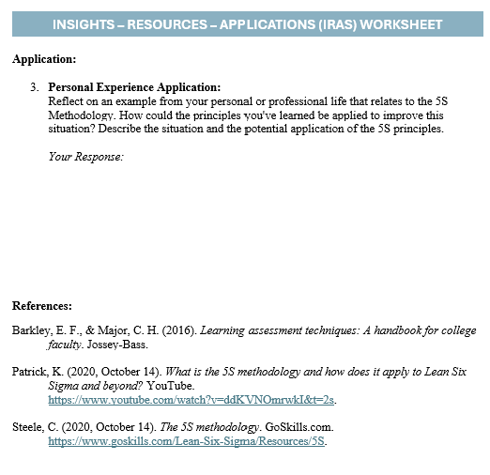

Appendix K
Digital Projects Activity
(Barkley & Major, 2016)
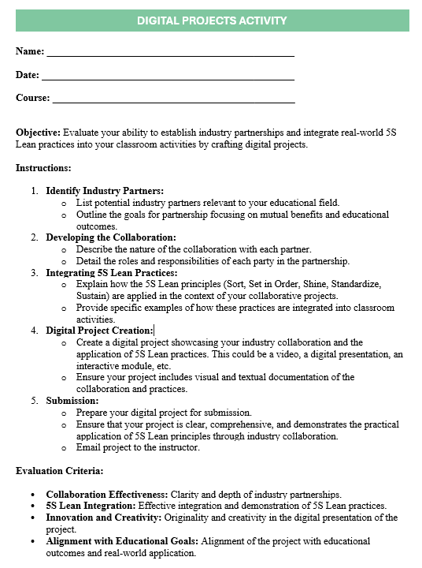
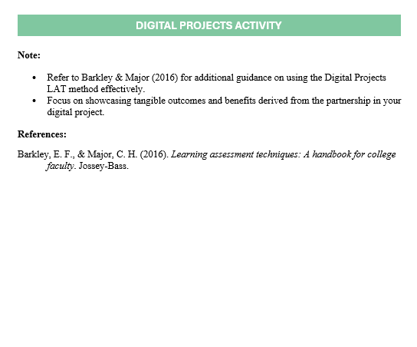

Appendix L
Role Play Activity Index Cards
(Barkley & Major, 2016; Formsbirds, 2024)
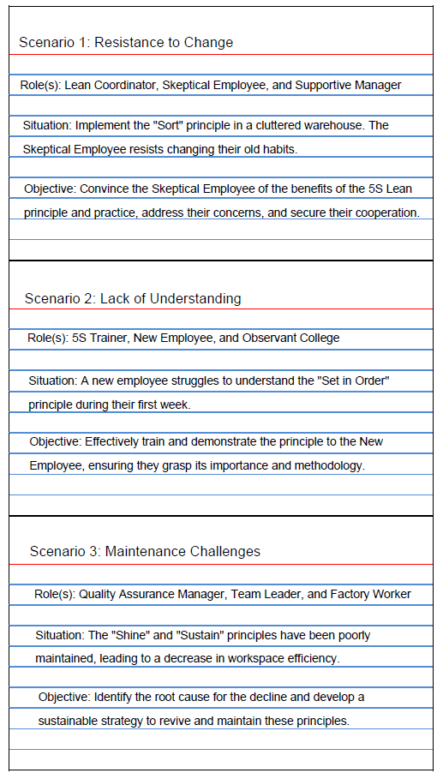
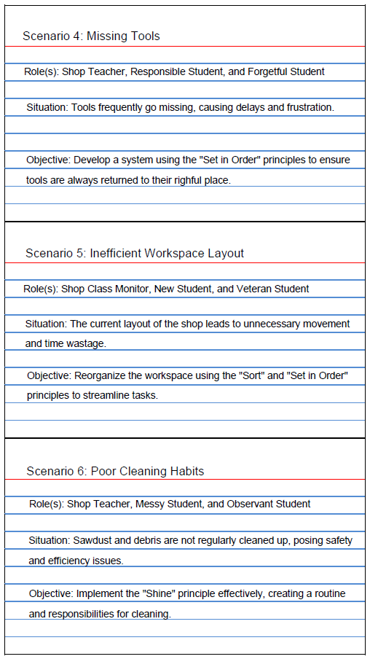
Appendix M
Peer Problem Review Activity Index Cards
(Barkley & Major, 2016; Formsbirds, 2024)
