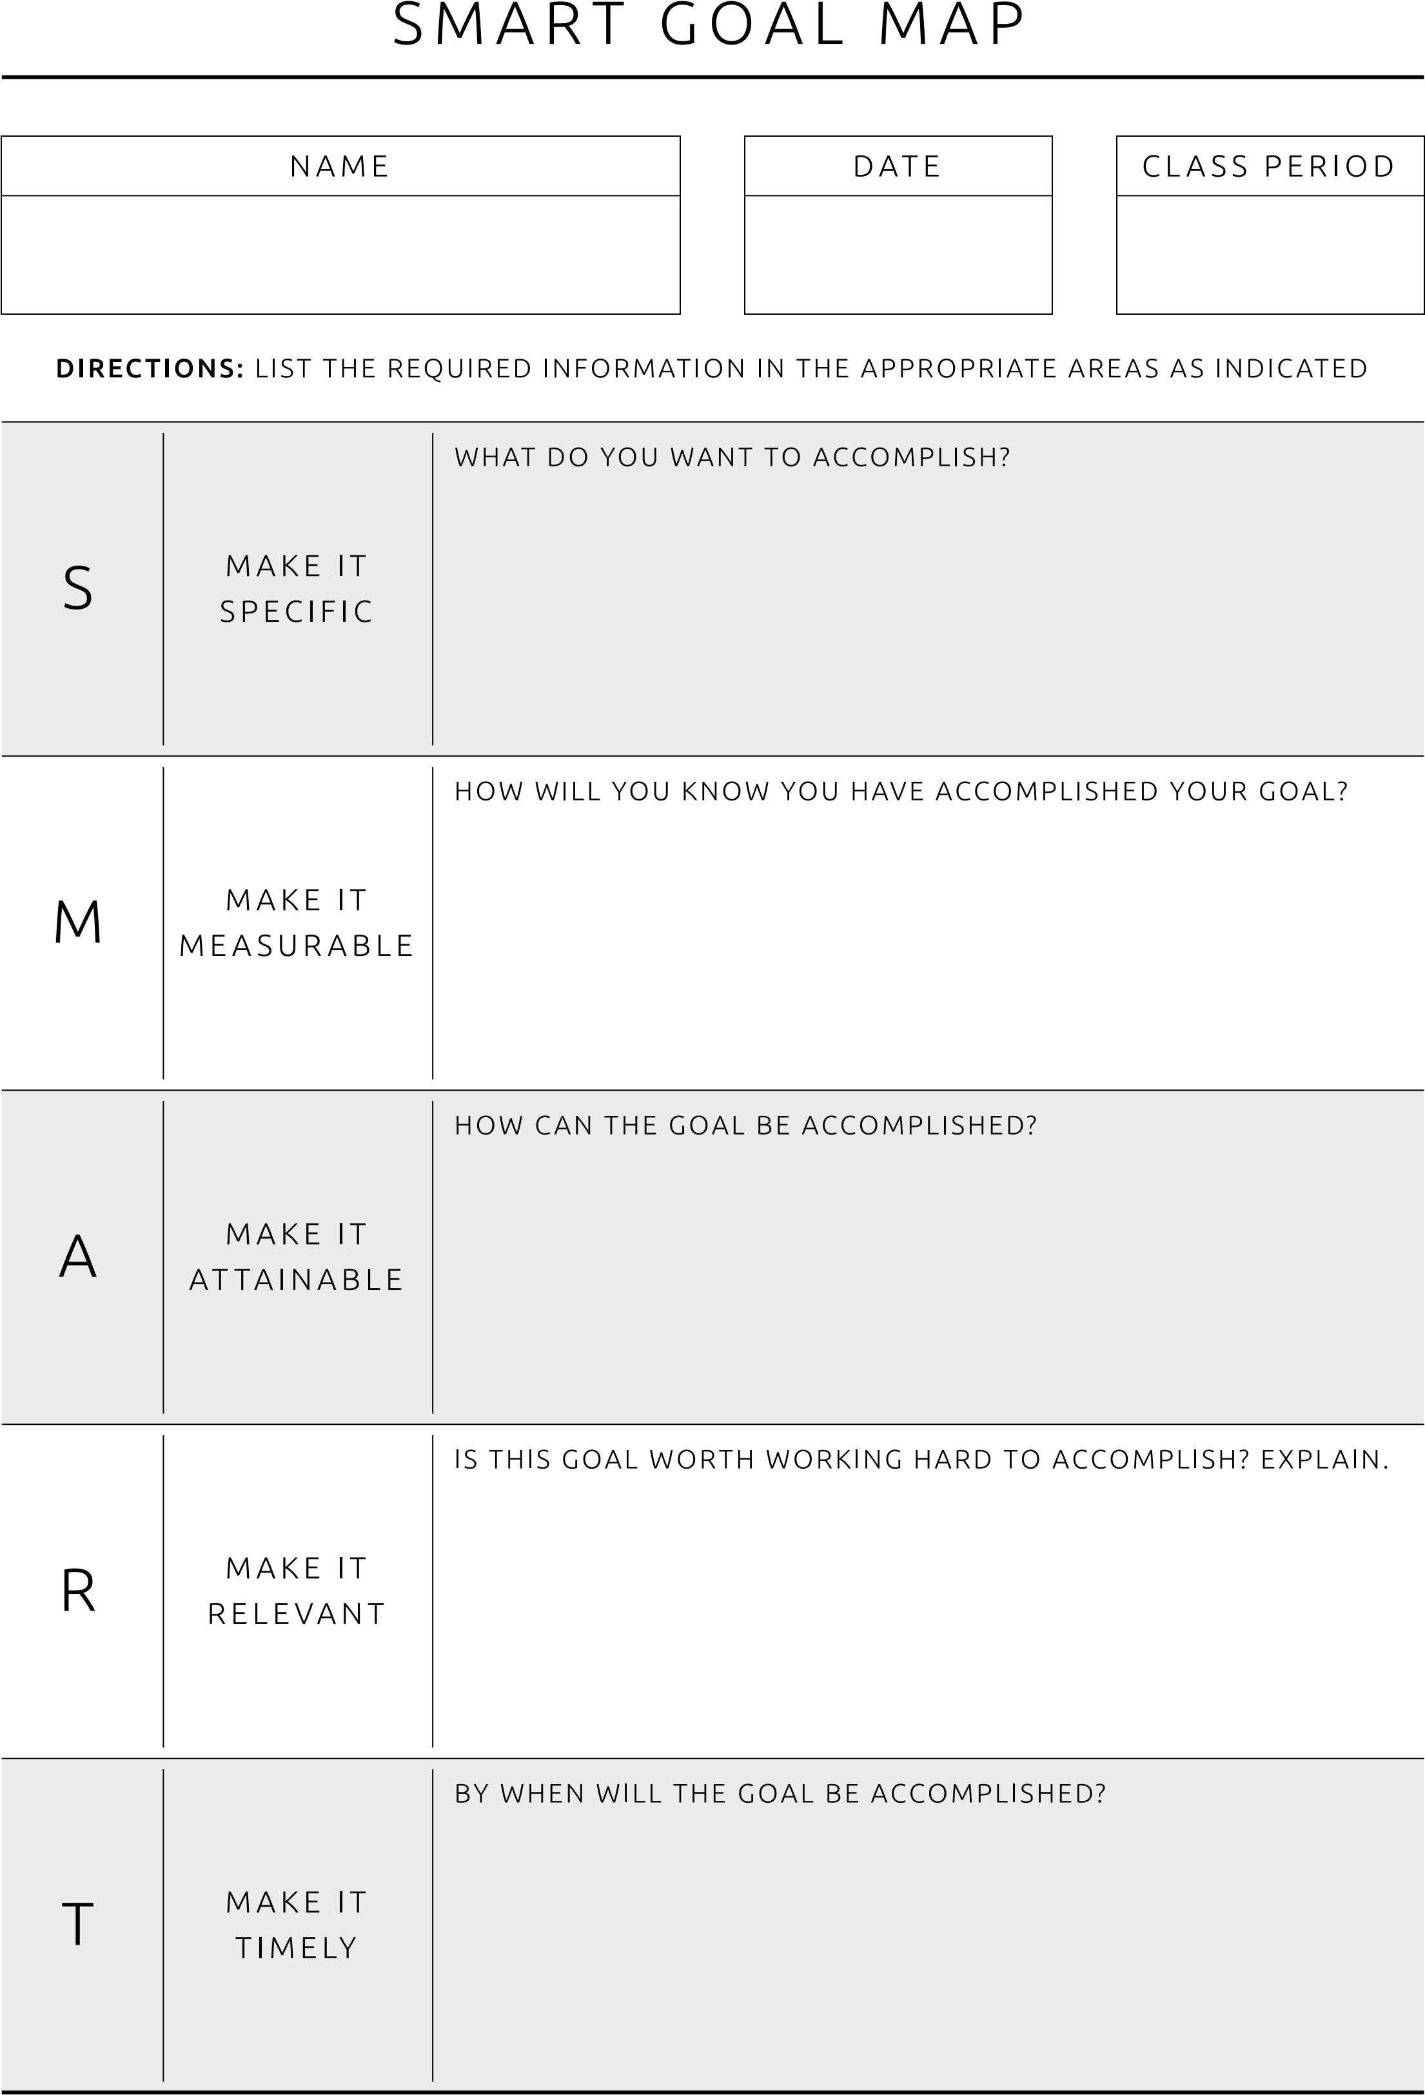
SMART GOAL WORKSHEET
IS THIS GOAL RELEVANT TO YOUR JOB? EXPLAIN.

DATE

NAME
BEMSID

